CLASSIC BISHOP SACRIFICES

One of the most useful pieces in attacking sacrifices is the bishop; being a long moving piece the bishop normally attacks pawns and pieces from afar.
The aim of bishop sacrifices is to demolish or open up the king position, then reinforcements of other pieces continue the attack until it delivers checkmate or win of big material.
When the king is still in the middle of the board, sacrifices on f7 or f2 square are common; being the weakest point in an attack in the opening stages.
In castled king positions during the middle game the squares g7 and h7 are the usual targets.
In case we are the defending side, we must be alert when long-range pieces are trained towards our important pawns protecting the king.

1/B 2/W 3/W
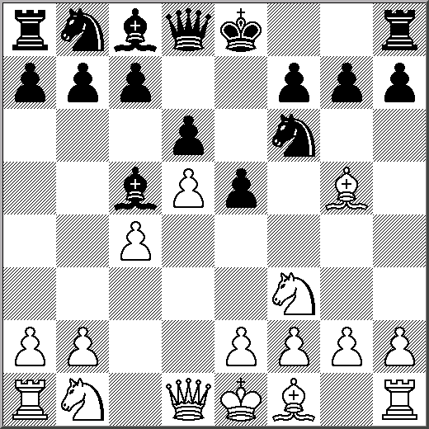
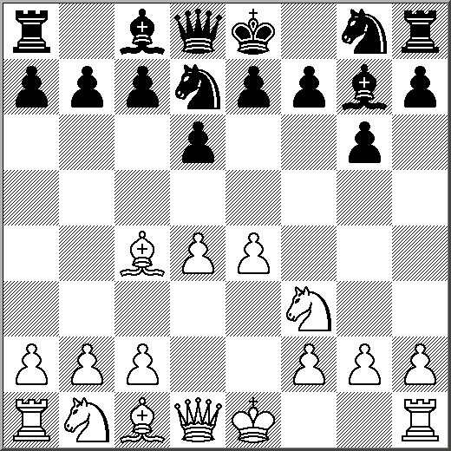
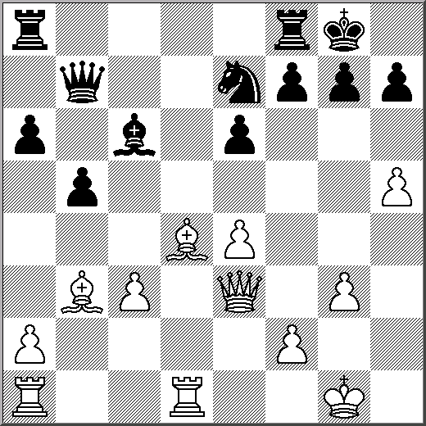

4/W 5/W 6/W

